**CURRICULAM VITAE**

**RUBHISHA A** 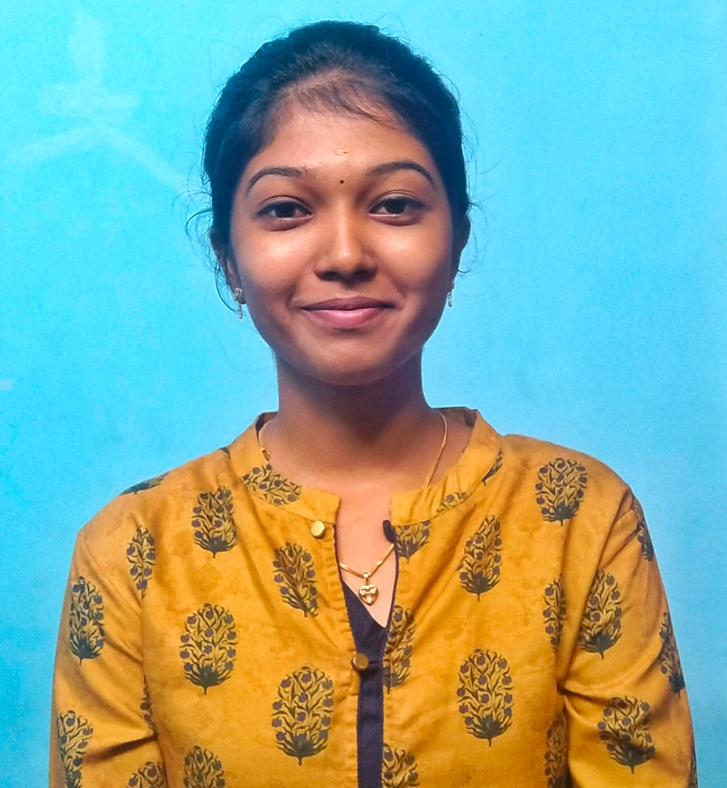

**Email Id :** [**rubhishashaalu87@gmail.com**](mailto:rubhishashaalu87@gmail.com)

**Contact : 6369554159**



To succeed in an environment of growth and excellence and earn a job

which provides me job satisfaction.



* Degree (B.Sc Computer Science) from S.T. Hindu college affiliated Manonmaniyam Sundaranar University with 80% in 2024.
* HSC from Little Flower Girls Hr Sec School with 88% in 2021.
* SSLC from Little Flower Girls Hr Sec School with 82% in 2019.



* Microsoft Office
* C, C++
* Java



* Tamil and English Typewritting.
* Time Management
* Team worker
* Communication and adaptability



* Tamil – Native speaker can read and write.
* English – Can skillfully speak , read and write.
* Hindi – can skilllfully speak, read and write.



I hereby declare the information given above is true to all my knowledge.